**Search Book Page**

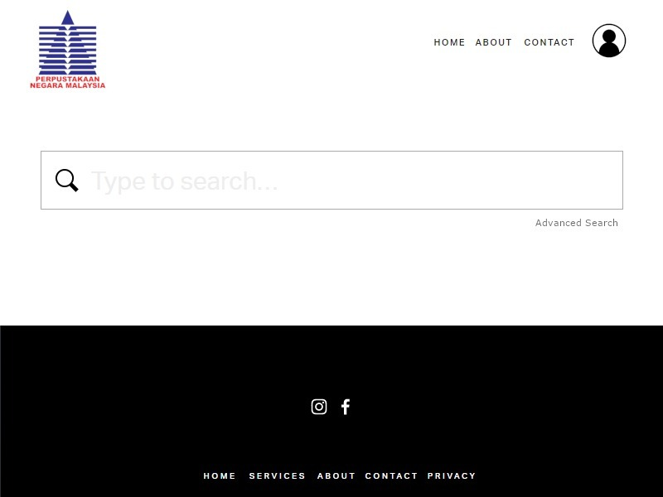

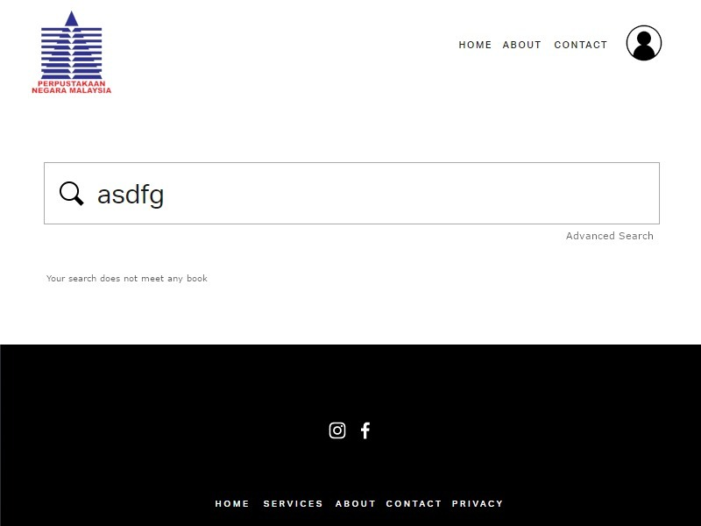

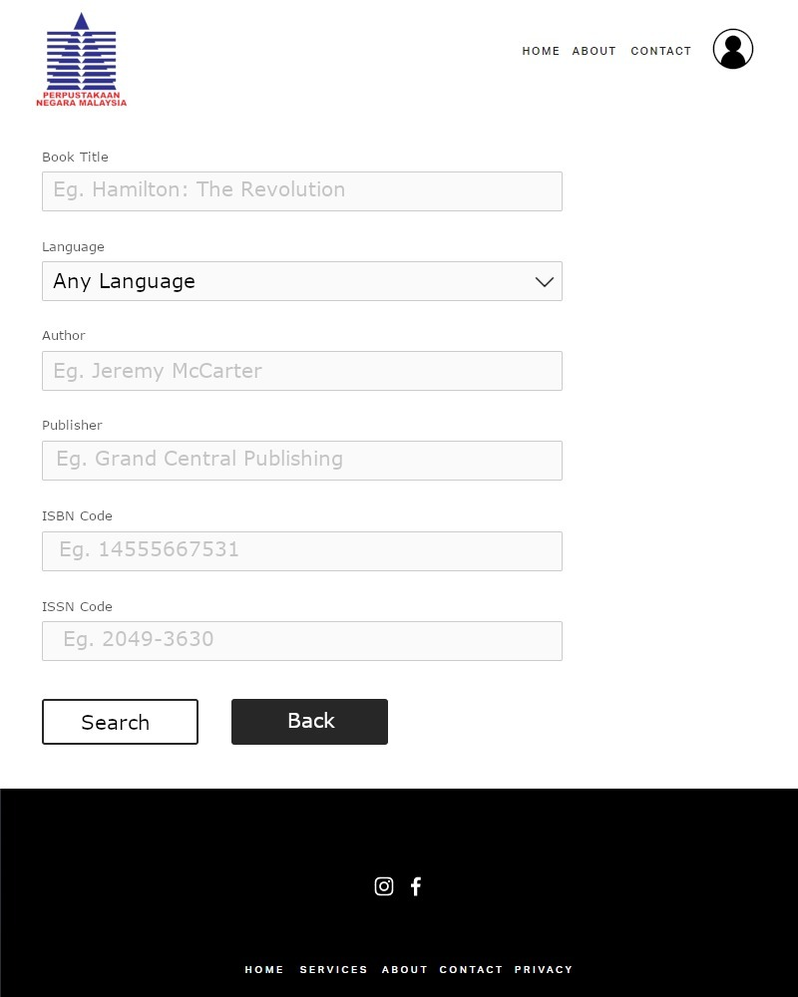

**User-Friendliness Characteristics**

**Ease of Data Entry**

* This is a search page for the National Library of Malaysia. The data entry screen in the same logical order as the input form. After that it also have a clear title of field and if user insert an invalidation data it has a provision of data validation checks in order to reduce potential human data entry error.

**Types of Data Validation**

**Existence check**

* The book of user wants to find is checked for the existence in library. If the book does not exist in library it will display an error to inform user and if the book is existing it will display the book information for the user.

**Register Page**

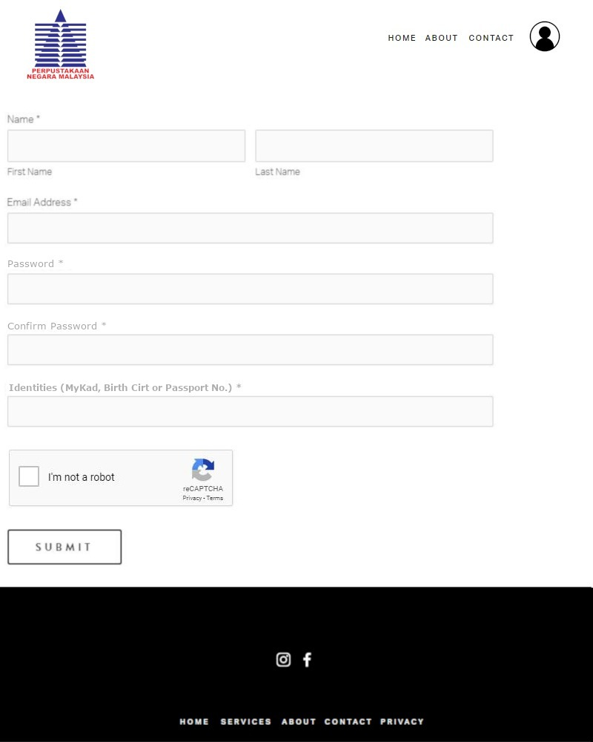

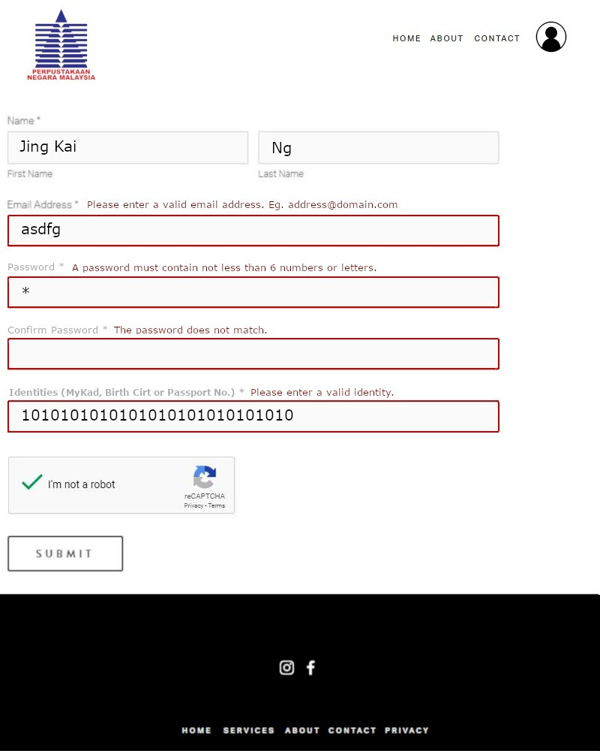

**User-Friendliness Characteristics**

**HELP Facilities**

* This is a register page for the National Library of Malaysia. It contains a hypertext in a box. This can help when users are unsure or unable to perform a certain function or made an error and it also accompanied by an example application of the command. When user key in invalid data it will suggest a correct alternative to the command that the user has specified.

**Types of Data Validation**

**Data Type check**

* No digit and symbol in the name check. No alphabetic data in identifier check.

**Format check**

* Use to check email format such as [xxx@gmail.com](mailto:xxx@gmail.com) .

**Payment Options Page**

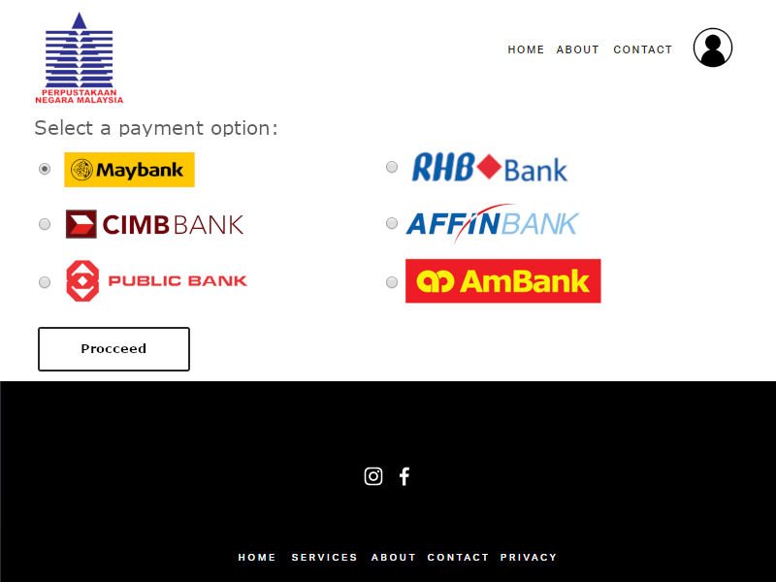

**User-Friendliness Characteristics**

**Default Value**

* The default value is set as Maybank, so if the user does not make an option for the payment option the process will be proceed as the Maybank.

**Types of Data Validation**

**Data Type check**

* No multiple options in the payment option check.

**Collection date**

